Question 2

Using Packet Tracer, simulate an ARP spoofing attack. Analyse the behaviour of devices on the network when they receive a malicious ARP response.

Approach

Make a simple LAN with two PC one attacker and another victum. Connect two PC with the switch and connect the switch to the router.

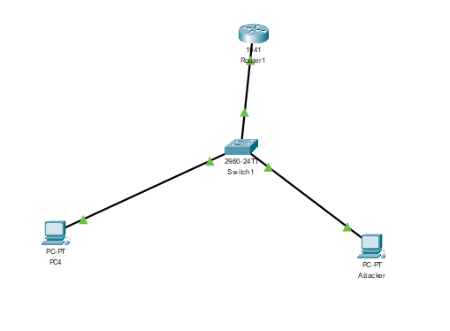

ping the router from victim and check arp table

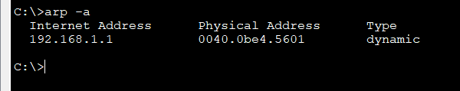

You can see the router mac address

Now ping router from attacker and get router mac address

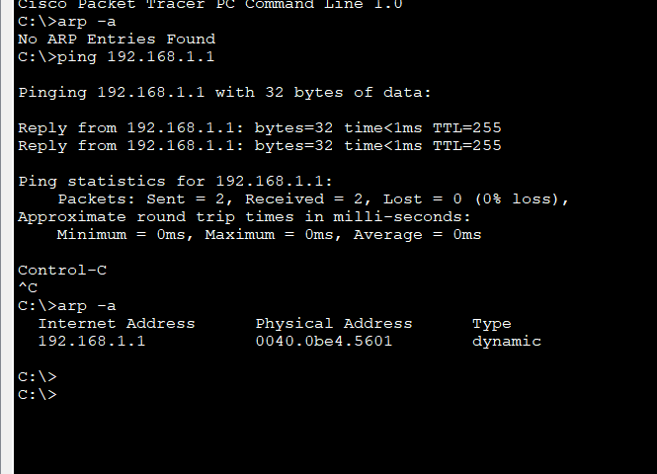

Cisco packet tracer will not allow o change te mac address though terminal. We have mac-changer in Linux distribution. Now change the Mac address of the attacker manually and ping the victim.

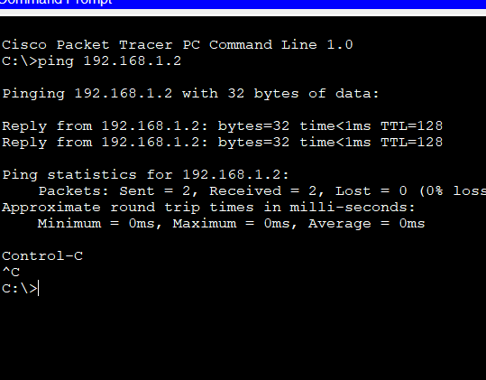

Mac address table before changing mac address

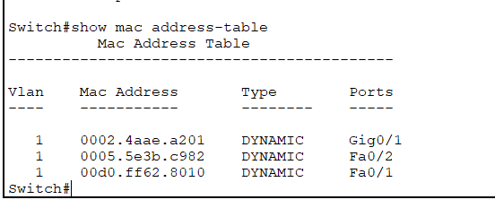

Mac address table after changing mac address

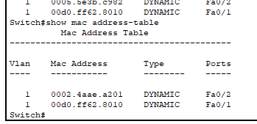

Now If you try to ping router, request will get timed out, the packet will be sent to Attacker

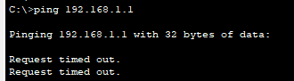

You can see the PDU of the packet on which des tip is mentioned as router.

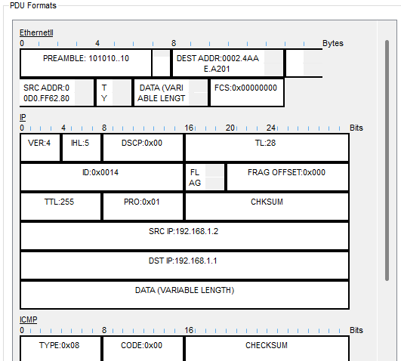

But the packet is transmitted to attacker.

